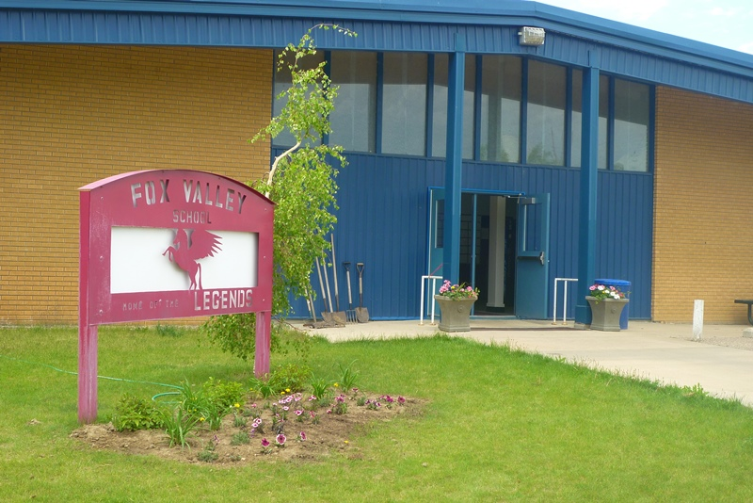
Fox Valley School Newsletter
November 2020

The 2019/2020 yearbooks have arrived!!!!! The cost of each yearbook is $50. If you would like one, please send a cheque made payable to Fox Valley School or cash in a well labelled envelope to the school.
Please NOTE: Because school came to an abrupt halt last year, the 2019/2020 yearbooks were NOT preordered by parents!!! So if you think you might have ordered a yearbook last year…you did NOT!!!
The money can be given to any teacher (who will then pass it on to where it needs to go) and you will receive your yearbook as soon as possible!
What’s Happening In The Classroom

November News from the K/1 Class

Rhyme Rhyme and more Rhyme
This month the students will be immersed in rhyme. We will listen for rhyme in stories and poems. We will sing rhyming songs. We will play rhyming games as a group and as individuals. We will play at rhyming centers.
It will be our goal for all K/1 students to be able to identify rhyme and produce our own rhyme.

The Grade One class have been learning to spell popcorn words (sight). After every 20 words we will have a popcorn party. We will have our first party on Tuesday, November 3rd. Great Job Grade One!!
The Kindergarten Class has been working hard learning the beginning letters and sounds of each other’s names. We will also celebrate with popcorn when we have that mastered. – Mrs. Hudec

WE WILL HAVE A TON OF FUN

Grade 2 & 3 - What an exciting time to be in Grade 2/3! I could not be prouder of my genius kiddos. In Science, we have been learning about the different types of animals and how they have physical and behavioural adaptations to help them survive. We are even creating our own animals with our own adaptations! In Math we have been learning about patterning and the different attributes of patterns. In ELA we have been continuing Daily 5 (and rocking it) as well as learning lots of phonics secrets to help us when reading and spelling. We have also started to look into building our comprehension skills and using reading strategies like "skippy frog" (ask your child!) to help us figure out unfamiliar words! Amazing! In Health we have started our community circle and it has been an amazing experience to hear about each other's lives and share things about ourselves in a safe and respectful environment. - Miss Peers

Grade 4/5 News
October
Mr. Kitzul

Grade 4/5 News

Hello all! Grade 4/5`s in the afternoon have Arts ed, Science, Physical Education, Health, and Social! Our year has been progressing with forming Dance routines in 4/5 Art which consists of learning the Structure of dance and how dance judges evaluate specific dance routines! In Science we are currently learning about how sound is created and how humans perceive sound in different mediums (air, gas, water, etc)! Phys ed and Health we are learning about stereotypes and peer pressures as well as learning the Tactics and Strategies behind the sport of Volleyball. And lastly, in 4/5 Social Studies, we are currently exploring how colonization has happened in early Canada and how it has affected the world we live in today. That is what is happening in the 4/5 classroom as of October!
October Birthdays:

Payton – October. 2nd
Kayanna – October. 15th
Dailon – October. 17th
Classroom reminders:
- Students are strongly encouraged to bring their masks home and wash them
- Students need to make sure to bring a mask to school everyday

Grade 4/5 - The new book we have been reading this month is a Willow nominee called Tales From Beyond the Brain. It has been a very fitting book for the month of October as the stories are a bit gruesome. We have also been working on an analyzing unit featuring the book Spiders by Seymore Simon. He is a very good non-fiction writer for our age group. We have also enjoyed working on a Halloween story called "Eyes Wide Open." The students have been working on these on the chrome books so parents can check into their work at home if you like.
The Math topic of the month has been place value, addition and subtraction. The Grade 5s have been working on numbers to 1 000 000 and the Grade 4s are working on numbers to 10 000. - Mrs. Hoffart

We did it! We made it through two months of school. We have been hard at work in the middle years math classroom. This month, instead of telling you what we have been studying, I decided to include some questions that you can ask your child to spark some discussion! We will be learning these concepts in the next week or two so if your child doesn't know the answer today, try again tomorrow!
Grade 6 - What is one advantage of using a variable to represent a pattern? How does this help you solve a problem?
Grade 7 - I am a 2-digit number. I have 3 factors. I am divisible by 5. Which number am I?
Grade 8 - What is the difference between a percent increase and a percent decrease? When could we use this in everyday life?
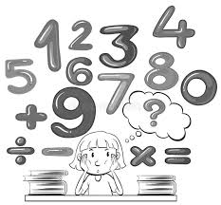
Grade 9 - What is a rational number? How is dividing rational numbers similar to multiplying them?

I hope that asking these questions will help to promote more of a discussion from the common "what did you learn today" question. - Mrs. Marsh

Grade 6/7 - We are already heading into our third month, time flies! We switched up our daily reading workshop in October and it is going really well. Students are reading independently to increase fluency and comprehension and I conference one on one with each of them throughout the week. Alongside reading, we are working on descriptive writing strategies and creating a descriptive paragraph about Remembrance Day. Grade 6 students will be writing about a place and grade 7 students will be writing about a person. We will then flip back and finish our Novel and write letters to a character in our book, Cowboys Don’t Cry.

In ELA 6 we are doing a variety of things to improve our writing. We have grammar gremlins, proofreading and editing practice, and the students are loving our writing centre days. We are just trying to decide on our next read aloud or reader’s theatre.
In health 6/7 we are finishing up our first unit with a role playing activity on good decision making. Next, we are moving into our second unit which looks at safety and first aid. – Mrs. Yeo

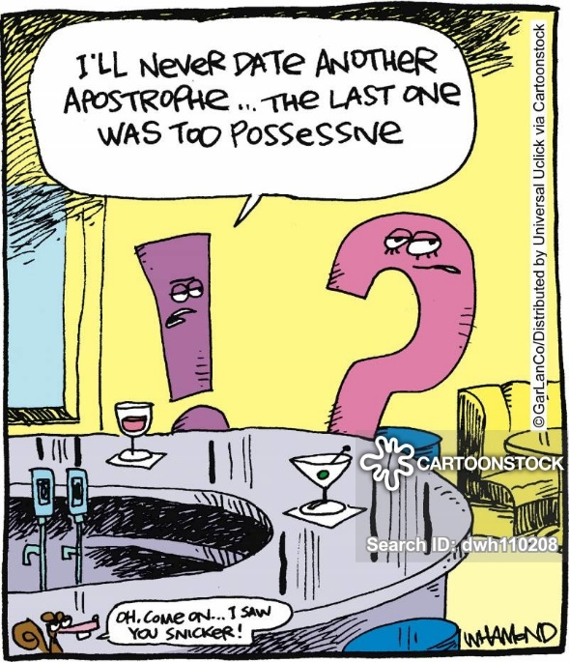

News From Miss Bakanec’s Classroom
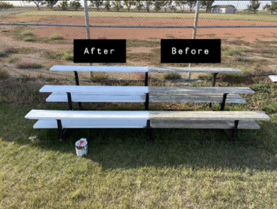
This month the grade 10 PAA class was busy doing community projects. The class started at the park in Fox Valley painting benches and a picnic table. After working at the park, we made our way over to the baseball diamonds where the students completed some of the small bleachers as well as the 2 large bleachers. They worked very hard to get as much done as possible in 2 weeks!

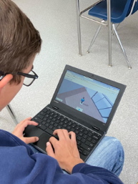

The PAA class is now finishing up the financial unit by designing and financing their dream home!

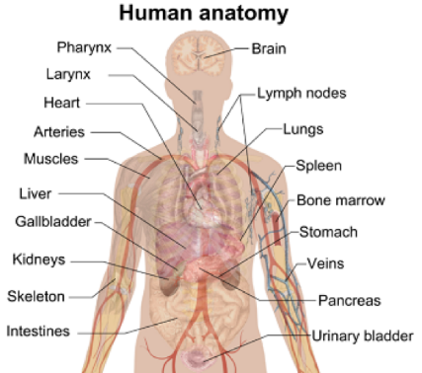

The Wellness 10 / P.Ed 20 class has been examining the relationship between proper nutrition and physical fitness. The students are currently planning a 3-day excursion where they discuss the food they will take with them and the nutritional value of the menu.

In English, the grade 10s are beginning a new novel called “Ender’s Game”. The novel is about a child genius who is selected by international military forces to save the world from destruction.

The Grade 11 class recently completed the “To Kill a Mockingbird” novel. The students learned a lot about discrimination and empathy as well as how these topics relate to society today. The Health Science 20 class is just finishing up the Human Body Systems unit! We will be doing a fetal pig dissection to close off the unit!

Arts Ed. 8 & 9 - Students created pictures, paintings, displays, and researched holidays during fall. Students are now working on a Remembrance Day assignment: create a poster, poem or essay. Students interested in putting an entry into the Veterans' Remembrance Day contests can talk to Mrs. Hellman about it.
ELA 8 & 9 - Grade 8 is finishing the unit on Global Citizens and grade 9 is finishing the unit of All That I Am. Both grades are reviewing (discussing Friday Files) and will be writing a test on the unit. Grade 8 writes on Wednesday, November 4; the Grade 9 test has not been decided yet.
Social 6 & 7 - Students are reviewing part 1 of unit 1. We are still reviewing. The test will be announced shortly.
Social 8 - Students are learning about how Canada's land influences our identity and how Canadians use the land.
Social 9 - Students are either researching an ancient society or creating an ancient civilization. We have finished the unit on Ancient Civilizations and Mesopotamia, and completed a review on the unit. The test will be soon.
Science 6 & 7 - Students are watching the decomposing of pieces of fruit and vegetables as a lab to see what things affect how the pieces decompose.
History 30 - Students are learning about the events that happened that encouraged Confederation and will be learning the steps to Canada becoming a country. - Mrs. Hellman

Grade 8/9 Arts Ed. Fall Projects
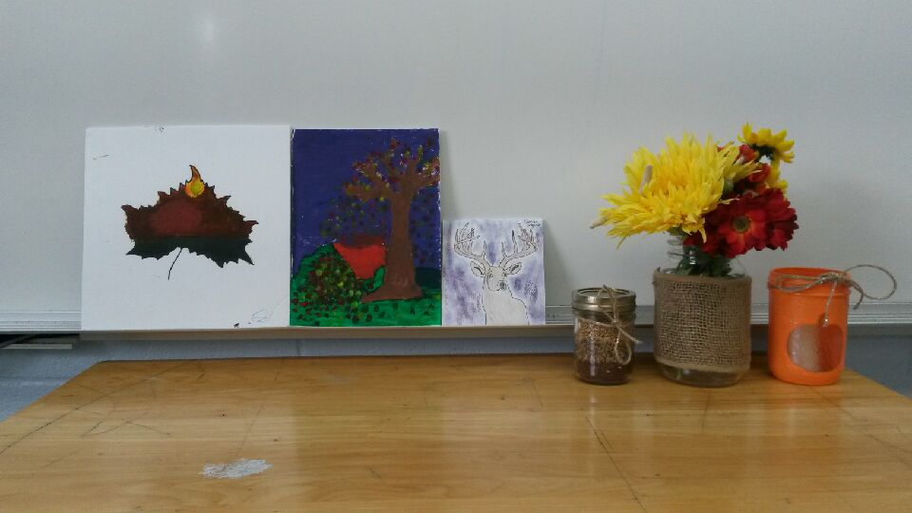
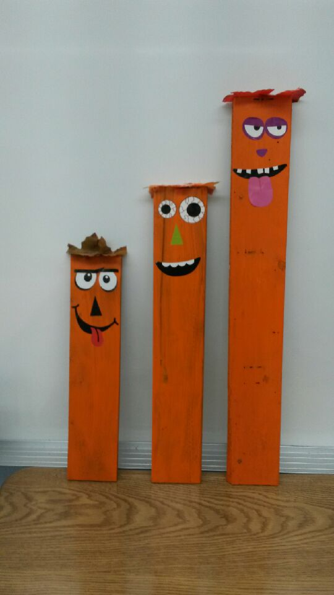
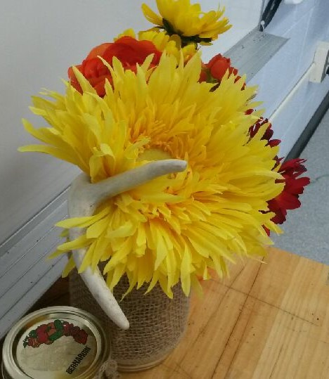

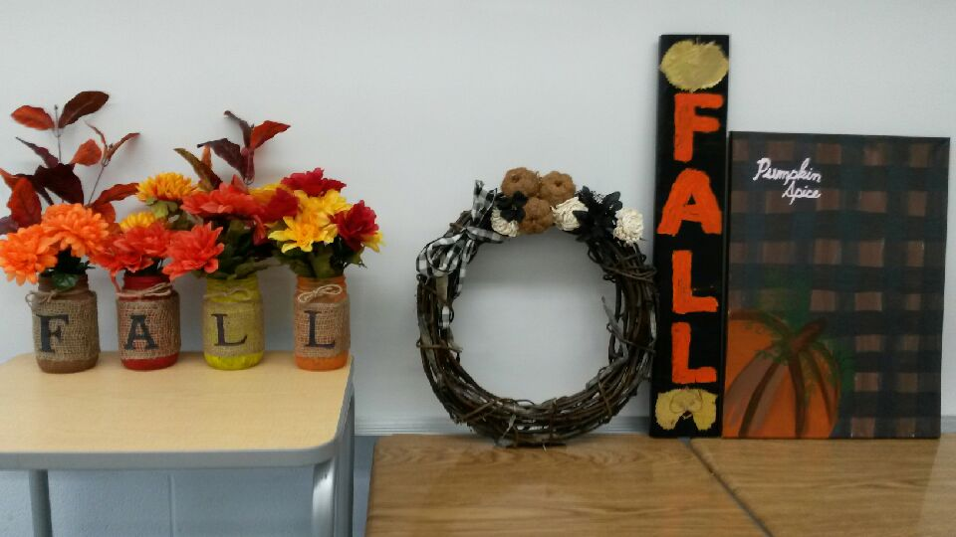
SRC
Each week the SRC will be having a spirit day in which students and staff are asked to dress up in the spirit of the day. Points will be awarded for participation and the winner in 2 month blocks will receive a trophy and bragging rights as being the cohort with the most spirit. This will start in November with November and December being the first set of points, January and February the second, etc… The students will be broken into 3 groups:
- Elementary Grades K – 5
- Middle Years Grades 6 – 9
- High School Grades 10 – 12 and staff

Each class that is given the spirit award will have their name put into a draw that will take place the end of February and the end of June, with the winning grade receiving up to $100 to purchase something for their classroom (a comfy chair, books, etc…)

NOVEMBER DRESS UP DAYS INCLUDE:
Wednesday, November 4th – Hat Day
Friday, November 13th – Superstition Day
Wednesday, November 18th – PJ Day
Wednesday, November 25th – Formal Day

The SRC is looking for more members!!! If you are interested, come to a meeting…see what we do…! Students in grades 7 and up are eligible to be on the SRC! We meet Mondays at noon in the library!

Fox Valley SCC News

SCC Members
Brittany Schafer
Brianne Schneider
Robyn Eresman
Sarah Koch
Tammy Welte
Edith Brilz
Ashely Dirk
Jody Brittner
Megan Schmaltz
Bev Hudec
Pat Wilde
Candice Kambeitz

Activities we have on the go:

Fruit Program for students
Bus Driver Appreciation Day November 23rd
Education week November 23-28

Next meeting date November 9th @ 7:00pm

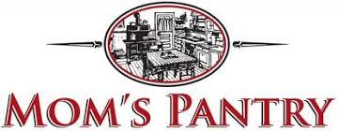

Thank you to everyone who supported our yearly fundraiser. We are hoping to hear soon about the delivery date. Please watch for further information on the date and procedures for pick up.

Please remember to call the school or make contact with your child(ren)’s teacher if they are NOT going to be at school!!!
Thank You!

Dates to Remember
November 4th – Hat Day
November 9th – SCC Meeting @ 7 p.m.
November 11th – Remembrance Day
November 11th – NO SCHOOL
November 13th – Superstition Day
November 13th – Grade 10-12 Report Cards will be E-mailed
November 18th – PJ Day
November 23rd – Bus Driver Appreciation Day
November 23rd -28th – Education Week
November 25th – Formal Day
November 27th – NO SCHOOL

